|  |
| --- |
| **UNIVERSITY MALAYSIA TERENGGANU**  **FACULTY OF OCEAN ENGINEERING TECHNOLOGY & INFORMATICS**  **[CSM3103]**  **FRONT-END PROGRAMMING**  **LAB REPORT**  **[Lab 5]**  **Prepared by:**  Muhammad Irfan Hakim bin Saharul Redzuan  (S62113)  **Prepared for:**  Dr. Rabiei b. Mamat  [**BACHELOR OF SCIENCE COMPUTER(MOBILE COMPUTING)** ]  SEMESTER II 2022/2023 |

**Task 1**

1. What is the name of first php file?

readproductline.php

1. What is the name of second php file?

getproductlist.php

1. Recognised the item in the select option.

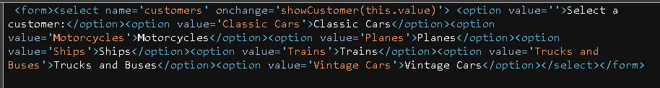

Classic Cars, Motorcycles, Planes, Ships, Trains, Trucks and Buses,

Vintage Cars.

1. What is returned by the second php file.

Return select option.

1. Can you examine how both file is called from html file?

Using XMLHttpRequest object created by JavaScript.

**Task 2**

1. How many records are there belonging to motorcycles type?

Answer: 13 records.

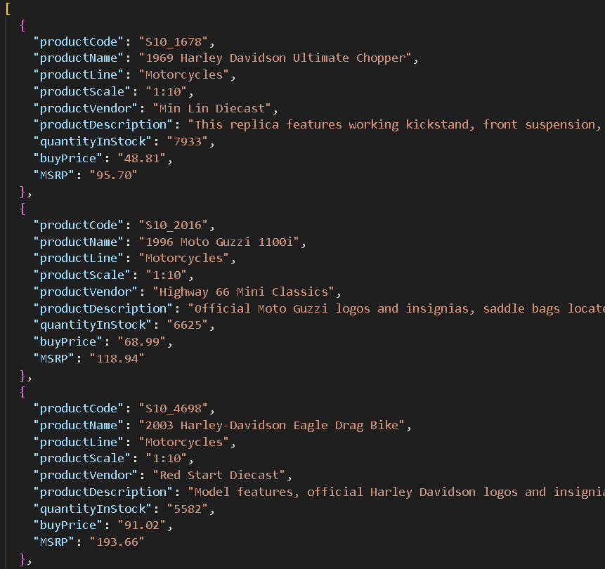

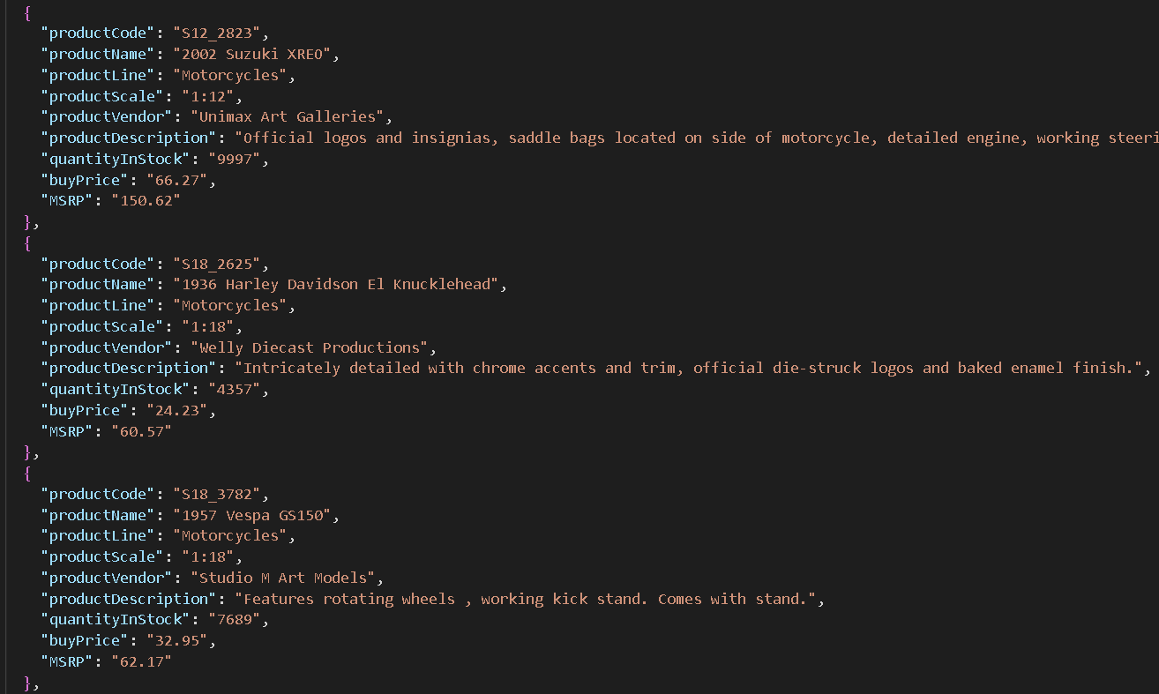

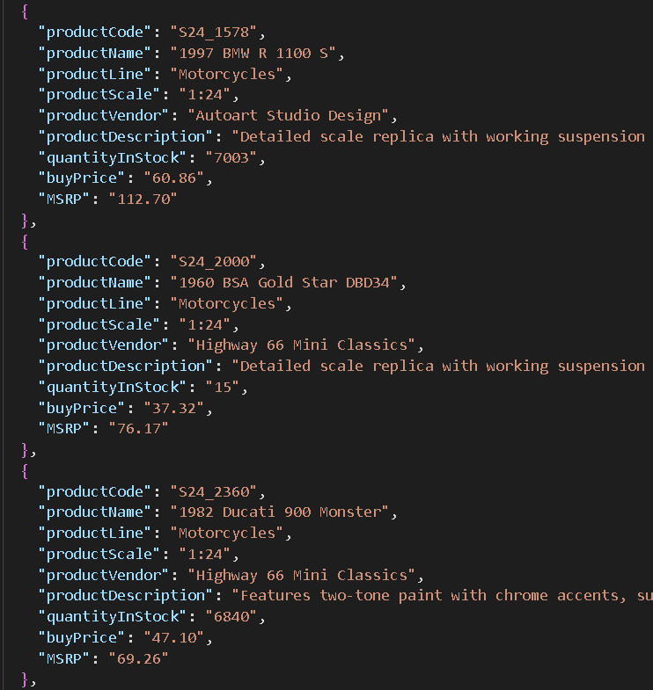

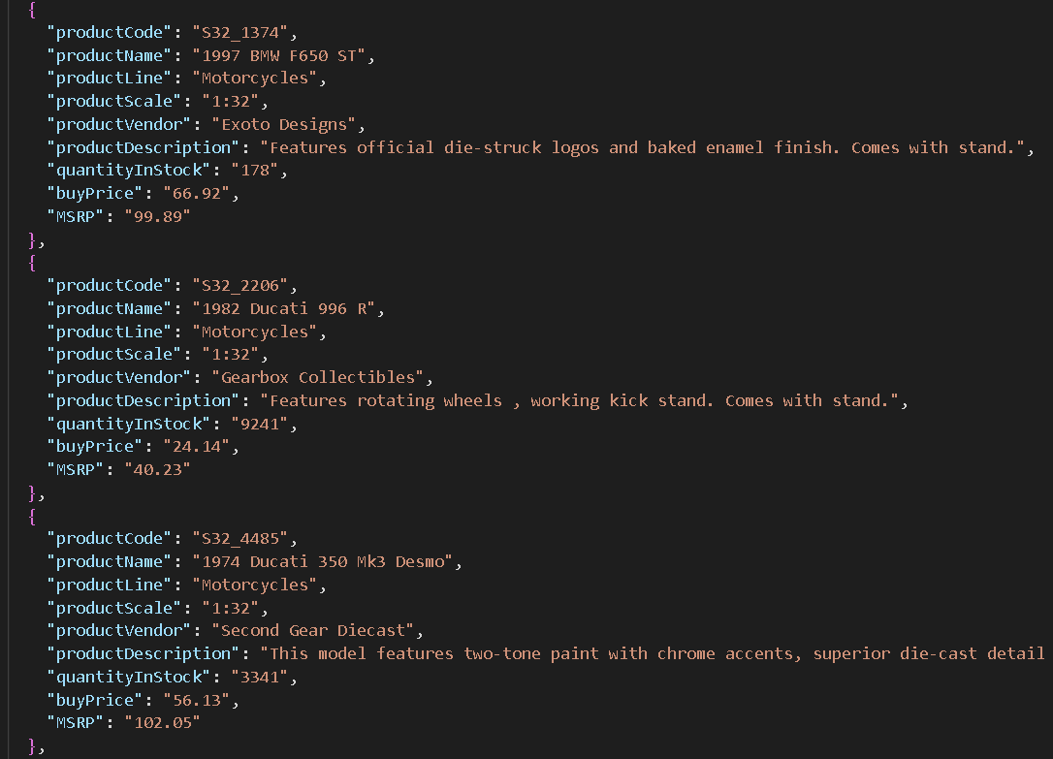

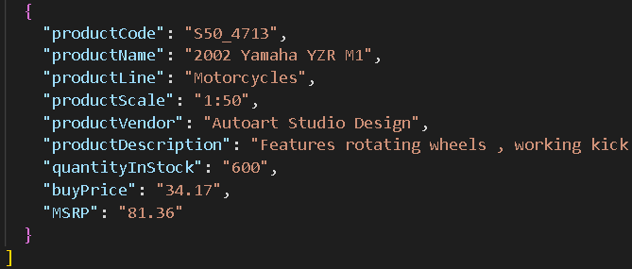

1. What are attributes in each of the record?

productCode, productName, productLine, productScale, productVendor, productDescription, quantityInStrock, buyPrice, MSRP.

Source code (index.html)

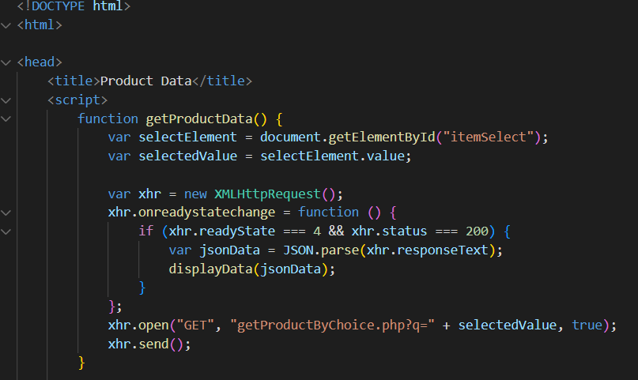

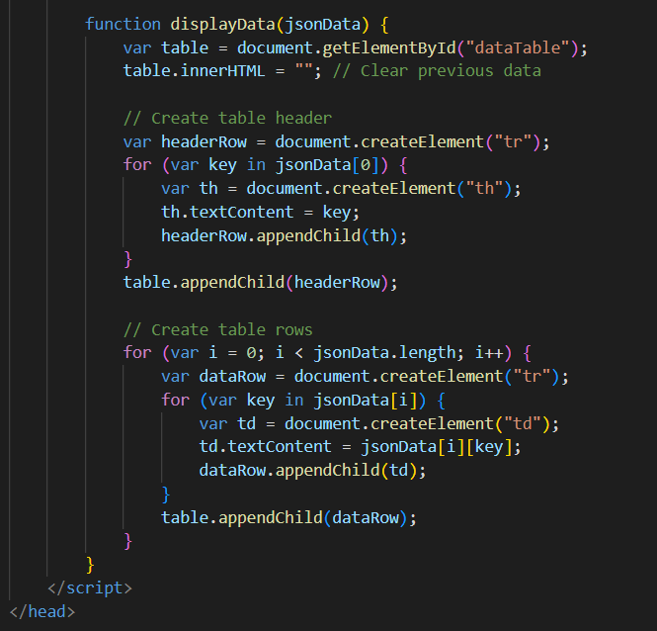

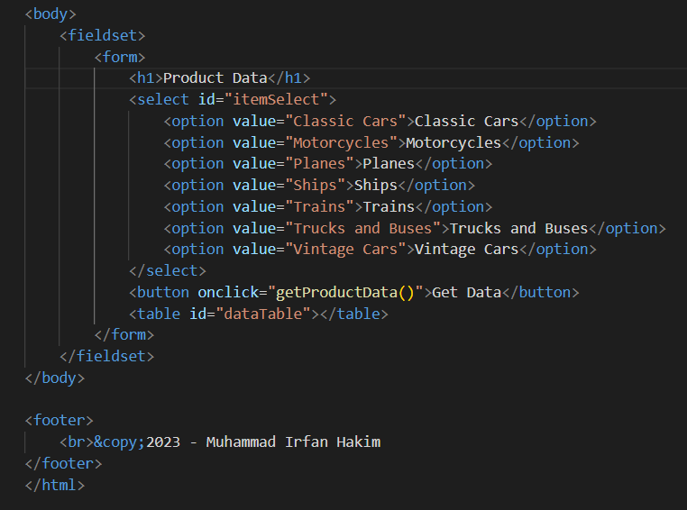

getProductbyChoice.php

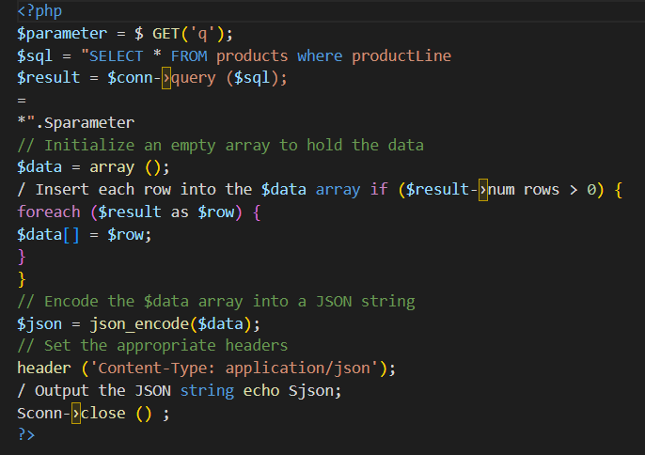

displayData.js

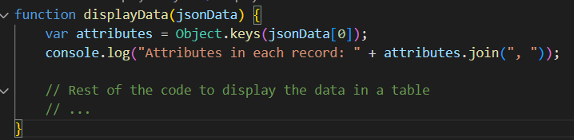

Output :

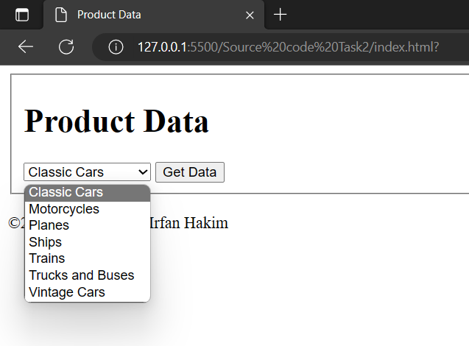

**Github link**